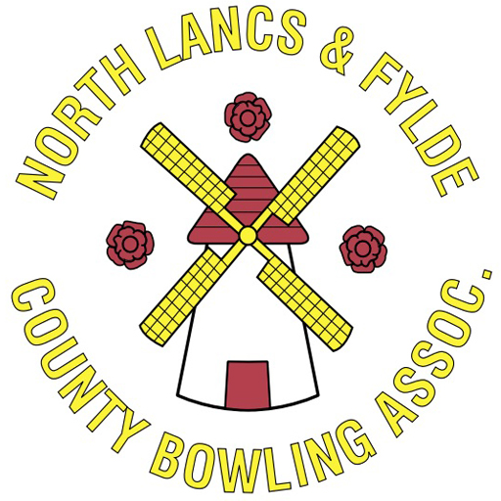
NL&F County Regional Representative

The role of the Regional Representative is to provide support to both the Regional Chairperson and the Management Committee to ensure the County sets, and meets, its goals and objectives, and that it is administered according to the County Bye Laws, whilst completing all legal and compliance obligations.

Roles & Responsibilities

- Act in the best interest of all affiliated members at all times.
- Communicating to affiliated clubs, either directly, or through the Regional Chairperson or County Secretary.
- Regularly attend Management Committee meetings and Regional meetings.
- Have a good working knowledge of the County Regions, Bye Laws, policies and procedures, as well as the roles of the Management Committee.
- Regularly liaise with the Management Committee to ensure they receive assistance and support, as required, and that the Management Committee report to affiliated Clubs on a regular basis.
- Ensure compliance and legislative obligations are met and the County meets its Safeguarding requirements.
- Undertake the role in good faith and honesty.

Knowledge and Skills Required
- Dedicated unbiased and impartial person that is receptive to change.
- Communicate effectively.
- Supportive of all affiliated members.
- Aware of the future direction and plans of the County.
- Well organised.
- Enthusiastic.
- Able to work well with people.
- Innovative thinker & receptive to new ideas.
- Prepared to make a regular time commitment.
- Friendly & outgoing.
- Diplomatic.
- A working knowledge of computers / email.
- Able to present and speak publicly.

Length of Appointment

The appointment of a Regional Representative is a one-year Term of Office.

Honoraria

The Regional Representative role is a voluntary position. All necessary expenses incurred to carry out the role will be reimbursed by the County.

