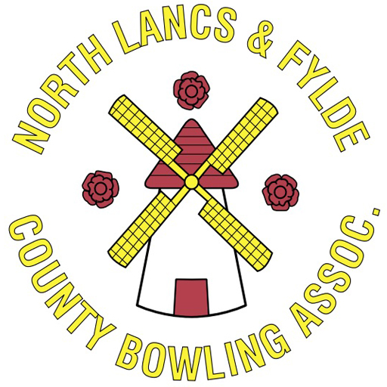
NL&F County Junior Secretary

The role of the County Junior Secretary is to understand the County Bye Laws, policies and procedures, legal and compliance obligations, and to ensure that the County is compliant in its actions. The County Junior Secretary is the primary point of contact for all affiliated Clubs, with regards to Junior competitions/events, and is responsible for ensuring the accurate calling and minuting of all meetings, whilst maintaining compliance with all Bye Laws.

Roles & Responsibilities

- Take detailed and accurate minutes of each Junior Committee meeting and General meeting and circulate them as required by the County Bye Laws.
- Prepare and circulate, according to the County Bye Laws, the notices/agendas convening all meetings, ensuring that all persons required are invited. If there are special resolutions to be considered at any meetings, then also to ensure that all requirements under the Club Bye Laws are met.
- Attend all Management Committee meetings and General meetings, as required.
- Handle, and circulate where necessary, all general correspondence, responding to any correspondence as required in a timely manner.
- To arrange and co-ordinate all aspects of Junior representative matches/competitions, for both BCGBA and Federation events. This includes, but is not limited to, correspondence to players, liaising with host club, liaising with catering, organising of transport, etc…
- Be the main point of contact, for general correspondence, for all affiliated Clubs and Leagues with regards to Junior participation.
- Maintain a register of the latest version of all County documentation including, but not limited to, Junior and Club contact details, Junior participation data, etc…
- To work closely with the Communications Officer to ensure that the County website and social media channels are updated in a timely manner, and that all information contained there is correct and accurate.
- To work closely with Regional Chairpersons to ensure that information is passed/received from all affiliated Clubs/Leagues within each Region.
- Co-ordinate any required training for the Junior Committee as required.
- Act in the best interest of junior bowlers and the affiliated Clubs/Leagues at all times.
- Undertake the role in good faith and honesty.

Knowledge and Skills Required
- Dedicated unbiased and impartial person that is receptive to change.
- Communicate effectively.
- Supportive of all affiliated members.
- Aware of the future direction and plans of the County.
- Well organised.
- Enthusiastic.
- Able to work well with people.
- DBS/Safeguarding certified.
- Innovative thinker & receptive to new ideas.
- Prepared to make a regular time commitment.
- Friendly & outgoing.
- Diplomatic.
- A working knowledge of computers / email.
- Able to present and speak publicly.

Length of Appointment

The appointment of County Junior Secretary is a one-year Term of Office, elected annually at the Annual General Meeting.

Honoraria

The County Junior Secretary role is an honorarium position. The role attracts an honorarium of £320. All necessary expenses incurred to carry out the role will be reimbursed by the County.
All honorarium payments are reviewed annually in conjunction to the requirements of the role.

