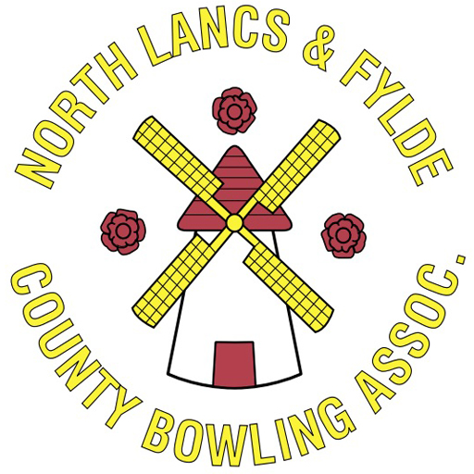
NL&F County Junior Chairperson

The role of the County Junior Chairperson is to be primarily responsible for ensuring the County conducts itself in a way that is beneficial to affiliated members. The Junior Chairperson reports to the Management Committee and works to ensure that the County meets the set goals and objectives, and that it is administered according to the County Bye Laws, whilst completing all legal and compliance obligations.

Roles & Responsibilities

- To chair all County Junior meetings and ensure that they are run in accordance with County Bye Laws.
- To call meetings, in a timely manner, and to ensure attendance from the Junior Committee. Agendas and minutes for all meetings should be prepared and circulated, in conjunction with the County Junior Secretary, in accordance with County Bye Laws.
- Facilitate discussion, maintain focus on agenda, and ensure fully informed decision-making takes place at all County meetings.
- Act as a spokesperson for the County Junior Committee and represent it locally, regionally and nationally as required.
- Act in the best interest of all affiliated members at all times.
- Communicating to affiliated Clubs, either directly, or through the County Junior Secretary.
- Have a good working knowledge of the County Regions, Bye Laws, policies and procedures, as well as the roles of the Management Committee.
- Regularly liaise with the Management Committee to ensure they receive assistance and support, as required, and that the Management Committee report to affiliated clubs on a regular basis.
- Regularly liaise with the Regional Chairpersons to ensure they receive assistance and support, as required, and that they also report to affiliated Clubs on a regular basis.
- Ensure compliance and legislative obligations are met and the County meets its Safeguarding requirements.
- Undertake the role in good faith and honesty.

Knowledge and Skills Required
- Dedicated unbiased and impartial person that is receptive to change.
- Communicate effectively.
- Supportive of all affiliated members.
- Aware of the future direction and plans of the County.
- Well organised.
- Enthusiastic.
- DBS/Safeguarding certified.
- Able to work well with people.
- Innovative thinker & receptive to new ideas.
- Prepared to make a regular time commitment.
- Friendly & outgoing.
- Diplomatic.
- A working knowledge of computers / email.
- Able to present and speak publicly.

Length of Appointment

The appointment of County Junior Chairperson is a one-year Term of Office.

Honoraria

The County Junior Chairperson role is a voluntary position. All necessary expenses incurred to carry out the role will be reimbursed by the County.

